Software Installation & Checking Procedure

Software Deployment Checklist
- Windows Server 2008 R2
- MS SQL Server 2005
- IIS 7.0
- .Net 3.5
- Microsoft Office 2003

Interface Application
Interface application Deployment File will follow the below structure,
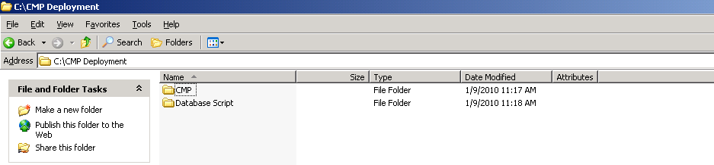

Folder Name | Folder Location | Description
DatabaseScript | C:\Database Script | All the Database Script related to the Content Management are located here.
CMP | C:\CMP | Copy the whole CMP folder to the <C drive>

Run Database script Sample, Pl. proceed in the same sequence in the “CMPCreationScript_V1.0.sql” file,
Double click the script from the DB Server,
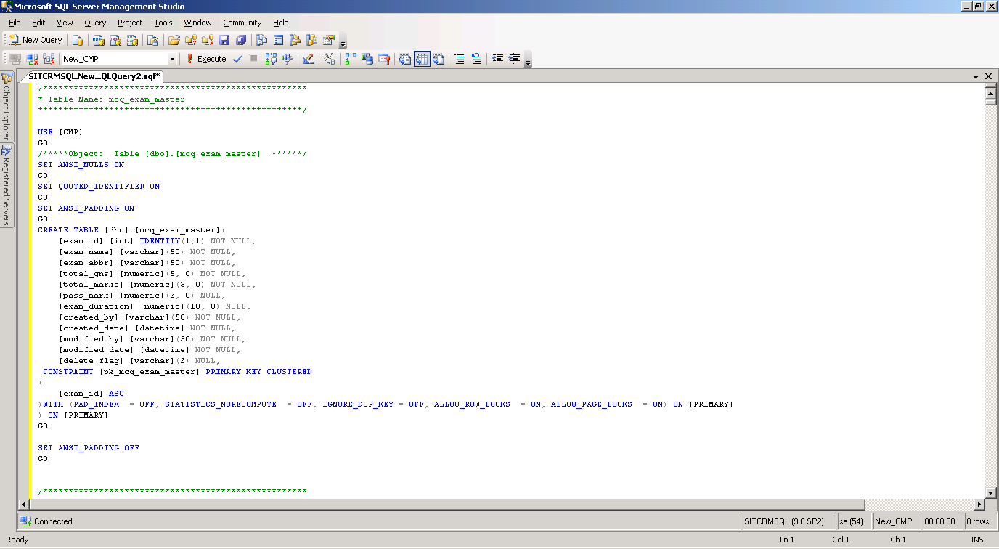
Click the Execute button to run the scripts.
Note: Use the account which has Database Creation Permission.

IIS Configurations
- Right click Site → select “Add Web Site”
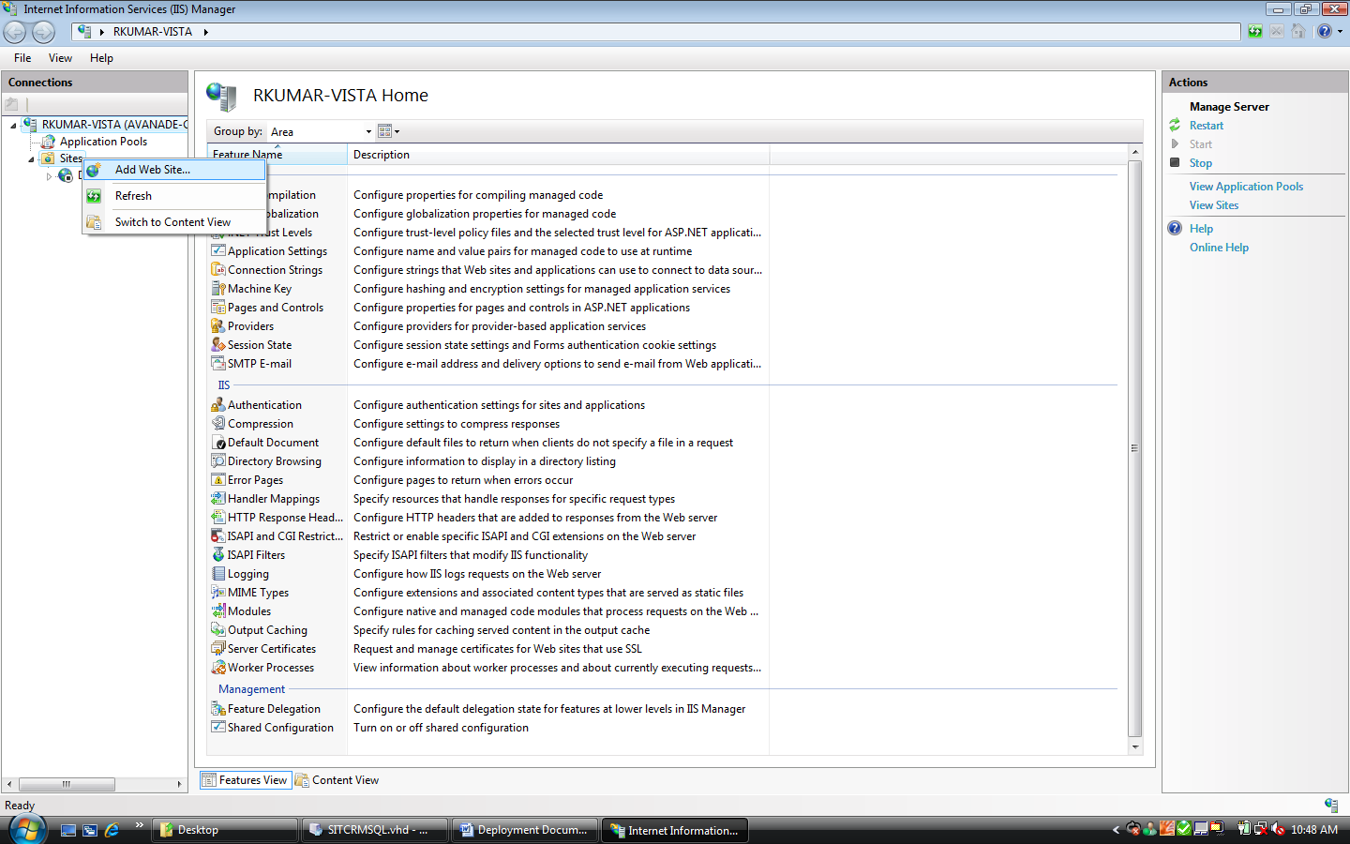
- Enter “ContentManagement” in Site Name and give the physical path as “C:\inetpub\wwwroot”. Then click “OK”
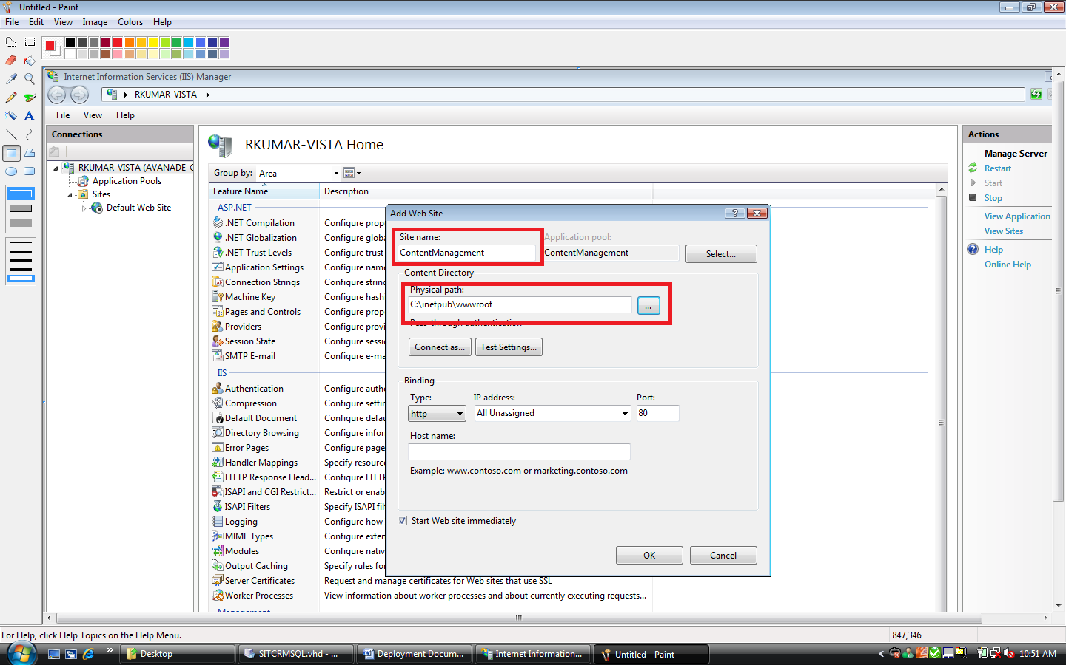
- Right click “ContentManagement” → select “Add Virtual Directory”
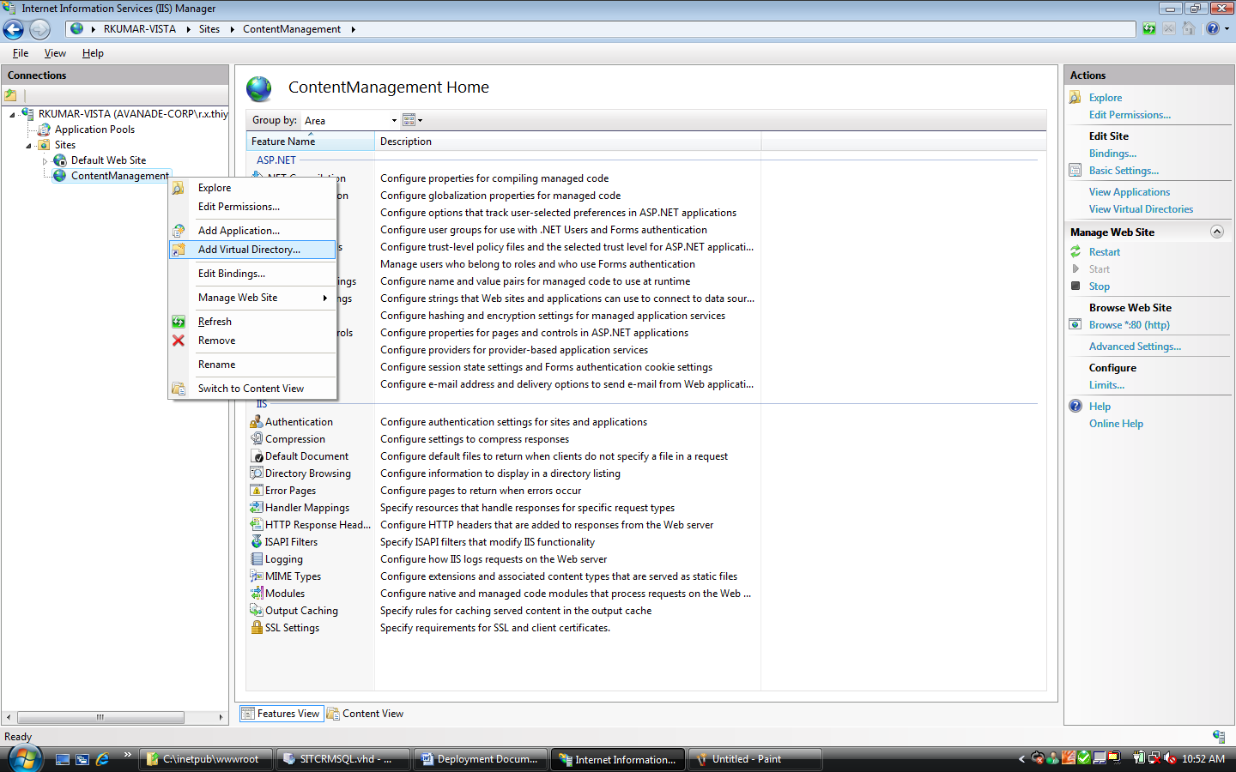
- Enter “CMP” in Alias and enter the physical path of the files you have copied “C:\CMP”. Then click “OK”.
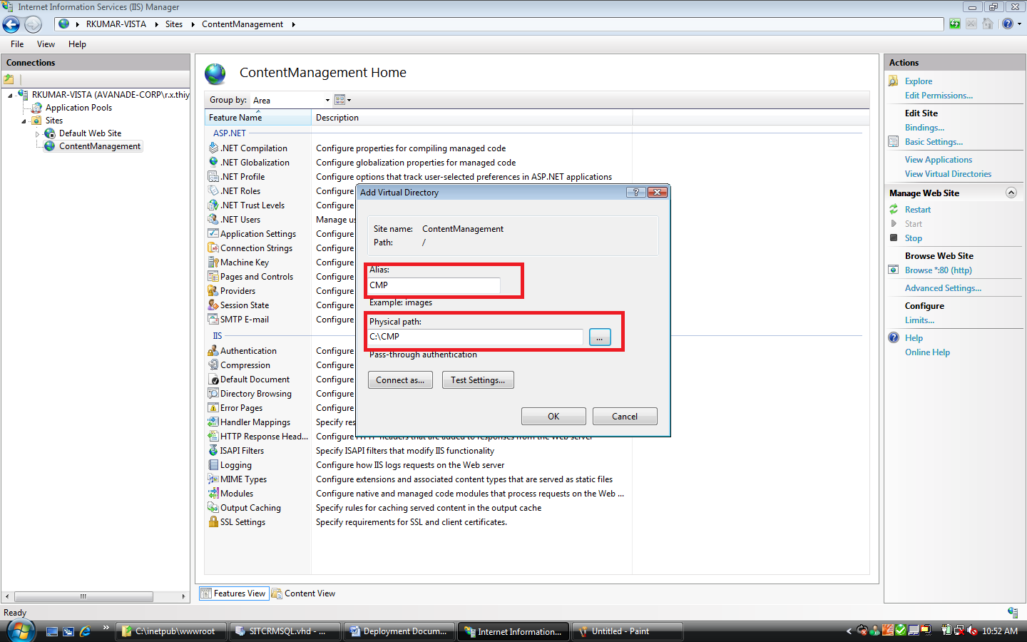
- Right click “CMP” → select “Convert to Application”
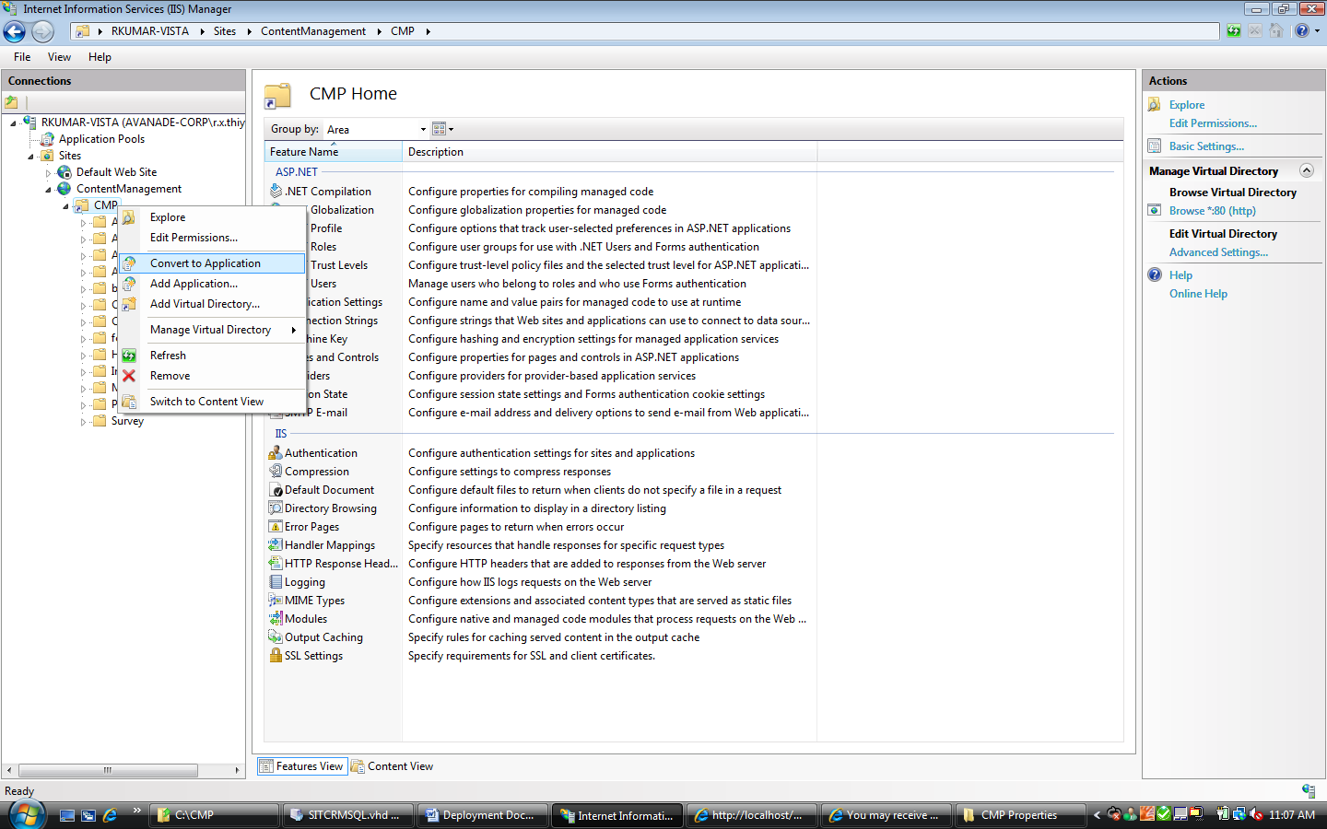
- Click “OK”
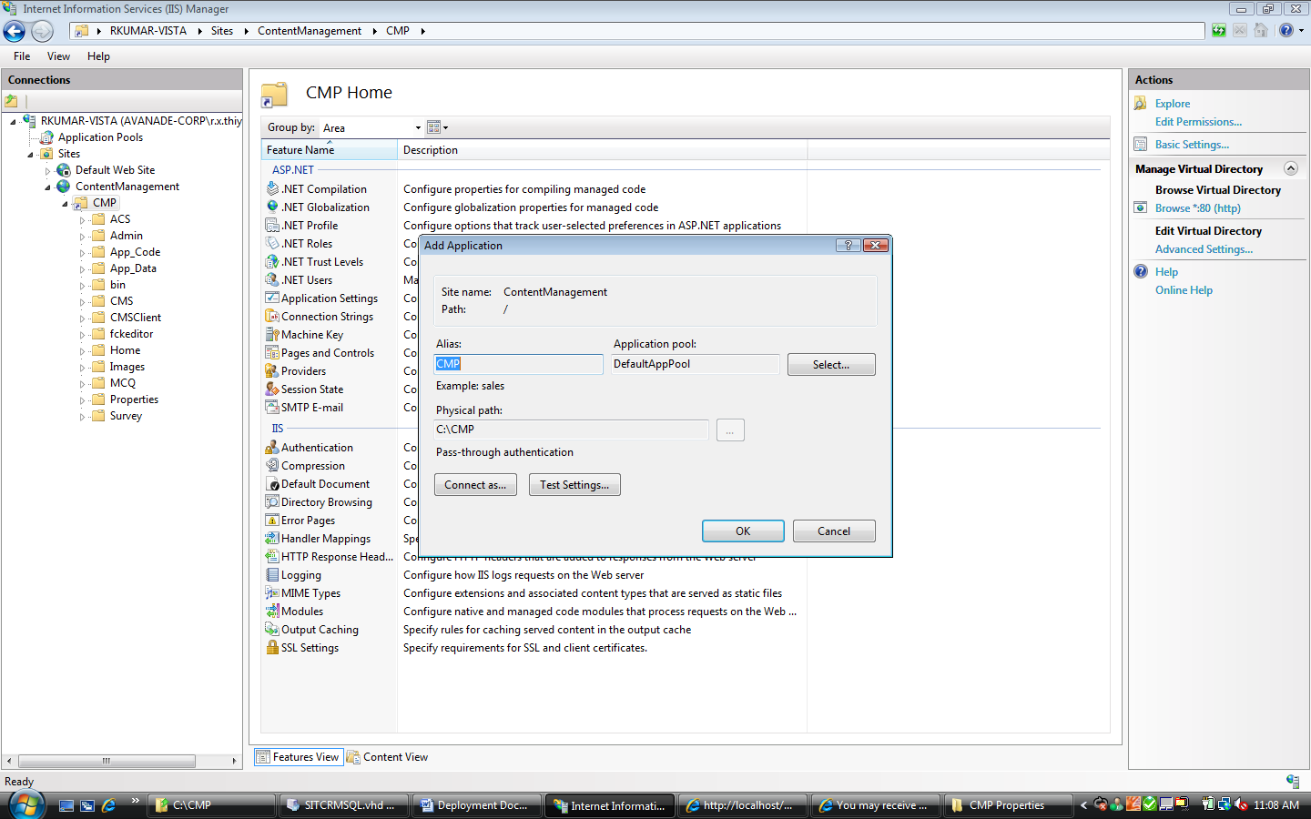
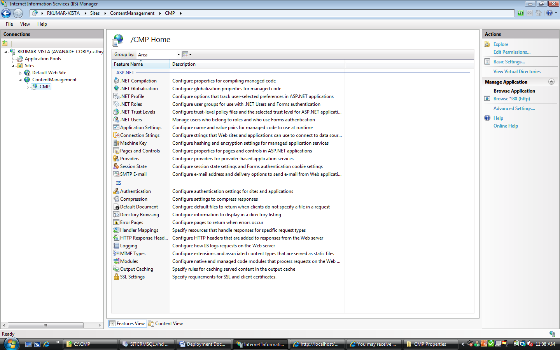

Configuration
- Open “C:\CMP\Web.config” in Notepad or Wordpad
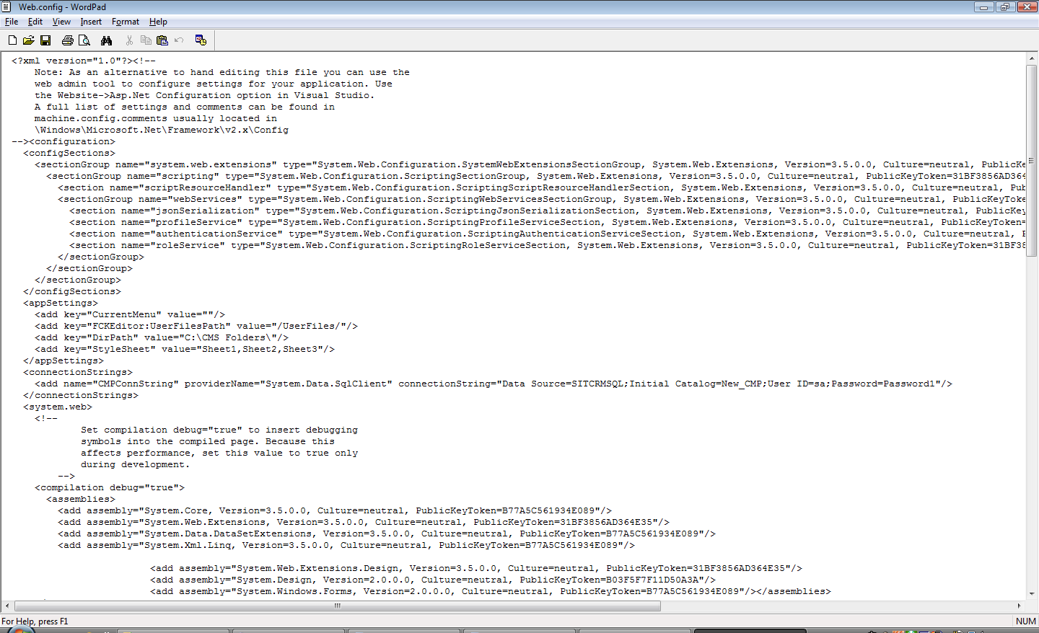
- Search for “CMPConnString”
- Change the connection string to your Database configuration “server=haiyangs\sql2005;uid=sa;pwd=Sa001;database=CMP;Pooling=false;Connect Timeout=30”
- Create a new folder “C:\CMS Folder”

